# Installing Swagger UI

Contents

Installing Swagger UI 1

Prerequisites: 2

Download swagger from git: 3

swagger-ui Installing steps: 3

Loading api definition with local dev build: 3

Swagger-ui API details page: 5

Swagger UI Request Page: 6

Swagger UI Response Page: 7

Try-out API's from Swagger UI: 7

Swagger HUB Enterprise edition: 8

**Installing Swagger UI**

## Prerequisites:

* git, any version
* Node.js >=14.21.3 and npm

Download and nodejs 14.21.3

**Note:** latest nodejs versions are not stable with some of swagger UI.  Node.js includes npm (6.14.18).

**Download link:** <https://nodejs.org/en/download/source-code>

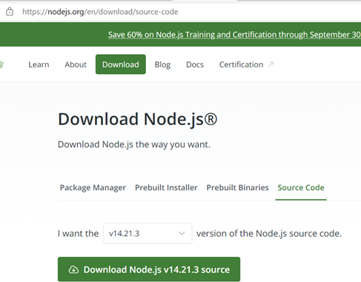

**Installing Swagger UI:**

## Download swagger from git:

<https://github.com/swagger-api/swagger-ui>

## swagger-ui Installing steps:

Get swagger-ui source code from git

* cd <INSTALLATION_PATH>/swagger-ui
* npm install
* npm run dev
* Wait a bit
* Open <http://localhost:3200/>

This will bring up swagger instance from your local machine.

## Loading api definition with local dev build:

Copy swagger yaml file in <INSTALLATION_PATH>\swagger-ui\dist

Make following changes in following swagger file.

<INSTALLATION_PATH>\swagger-ui\dist\index.html

   window.onload = function() {

      // Begin Swagger UI call region

      const ui = SwaggerUIBundle({

      url: "./anet-swagger.yaml",

        dom_id: '#swagger-ui',

Bounce/start the running swagger-ui instance.

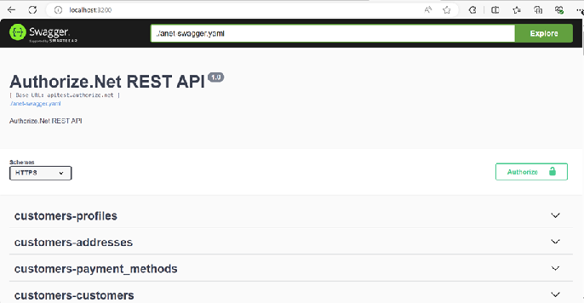

API's in swagger spec file can be categorized using tags in swagger file.

**paths:**

  /v1/customers:

    post:

      tags:

        - customers-profiles

### Swagger-ui API details page:

### Swagger UI Request Page:

### Swagger UI Response Page:

### Try-out API's from Swagger UI:

* Browse to specific API by category.
* Expand API from the list
* Click on Try-it out button.
* Enter all required information.
* Click on Execute.

You will see the response  from API call.

### Swagger HUB Enterprise edition:

SwaggerHub is an integrated API design and documentation platform, built for teams to drive consistency and discipline across the API development workflow. Swagger HUB has more features than their opensource Swagger-UI developer tool. Swagger HUB is available in both as SAAS and onPremis service. Download Swagger Hub from the following link.

#### Swagger HUB download link:

[https://swagger.io/tools/swaggerhub/](https://nam10.safelinks.protection.outlook.com/?url=https%3A%2F%2Fswagger.io%2Ftools%2Fswaggerhub%2F&data=05%7C02%7Cfanrodri%40visa.com%7C43edc64c3b354145ec4c08dcddb9c243%7C38305e12e15d4ee888b9c4db1c477d76%7C0%7C0%7C638629037164528843%7CUnknown%7CTWFpbGZsb3d8eyJWIjoiMC4wLjAwMDAiLCJQIjoiV2luMzIiLCJBTiI6Ik1haWwiLCJXVCI6Mn0%3D%7C0%7C%7C%7C&sdata=kP8Z%2FpTS%2B%2Bnlxg%2Fv4eA7p%2Fgeo7cfcyMMpET%2FBPU9588%3D&reserved=0)

#### Swagger HUB home screen

Swagger HUB API browser screen:

**END OF DOCUMENT.**